**Structure**

**1) Student Info:**

**import** java.util.Scanner;

**class** Student

{

**int** rno;

String sname;

**double** per;

**void** accept()

{

Scanner sc=**new** Scanner (System.***in***);

System.***out***.println("Enter Roll_No:\nName:\nPercentage:\n");

rno=sc.nextInt();

sname=sc.next();

per=sc.nextDouble();

}

**void** display()

{

System.***out***.println("Roll_No="+rno);

System.***out***.println("Name="+sname);

System.***out***.println("Percentage="+per);

}

}

**public** **class** StudentDemo {

**public** **static** **void** main(String[] args) {

**int** i,n;

Scanner sc=**new** Scanner (System.***in***);

System.***out***.println("Enter no of students :");

n=sc.nextInt();

Student s1[]=**new** Student[n]; //array creation

**for**(i=0;i<n;i++)

{

s1[i]=**new** Student(); //object creation

s1[i].accept();

s1[i].display();

}

}

}

**O/P:**

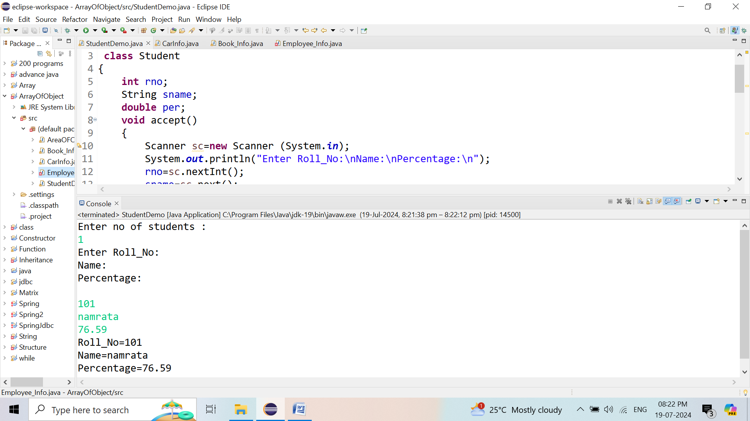

**2) Book Info:**

**import** java.util.Scanner;

**class** Book

{

**int** bid;

String bname;

String author;

**double** price;

**void** accept()

{

Scanner sc=**new** Scanner (System.***in***);

System.***out***.println("Enter\nBook Id:\nBook Name:\nBook Author:\nBook Price:");

bid=sc.nextInt();

bname=sc.next();

author=sc.next();

price=sc.nextDouble();

}

**void** display()

{

System.***out***.println("Book Id ="+bid);

System.***out***.println("Book Name ="+bname);

System.***out***.println("Book Author ="+author);

System.***out***.println("Book Price ="+price);

}

}

**public** **class** Book_Info {

**public** **static** **void** main(String[] args) {

**int** i,n;

Scanner sc=**new** Scanner (System.***in***);

System.***out***.println("Enter no of Book:");

n=sc.nextInt();

Book s1[]=**new** Book[n]; //array creation

**for**(i=0;i<n;i++)

{

s1[i]=**new** Book(); //object creation

s1[i].accept();

s1[i].display();

}

}

}

**O/P:**

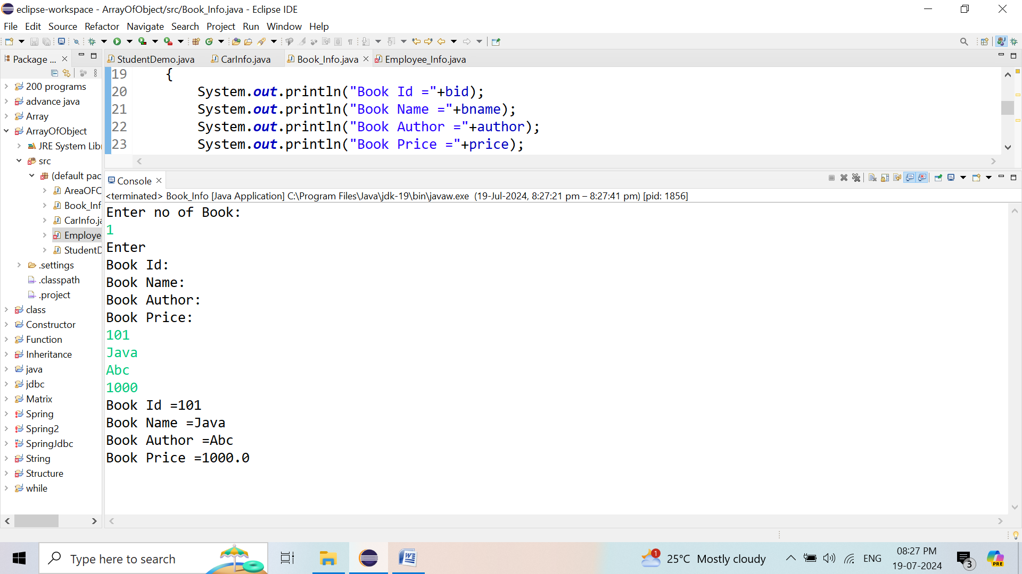

**3) Car Info:**

**import** java.util.Scanner;

**class** Car

{

**int** cno;

String cname;

**double** price;

**void** accept()

{

Scanner sc=**new** Scanner (System.***in***);

System.***out***.println("Enter\n Car No:\nCar Name:\n Car Price:");

cno=sc.nextInt();

cname=sc.next();

price=sc.nextDouble();

}

**void** display()

{

System.***out***.println("Car No="+cno);

System.***out***.println("Car Name="+cname);

System.***out***.println("Car Price="+price);

}

}

**public** **class** CarInfo {

**public** **static** **void** main(String[] args) {

**int** i,n;

Scanner sc=**new** Scanner (System.***in***);

System.***out***.println("Enter no of Car :");

n=sc.nextInt();

Car s1[]=**new** Car[n]; //array creation

**for**(i=0;i<n;i++)

{

s1[i]=**new** Car(); //object creation

s1[i].accept();

s1[i].display();

}

}

}

**O/P:**

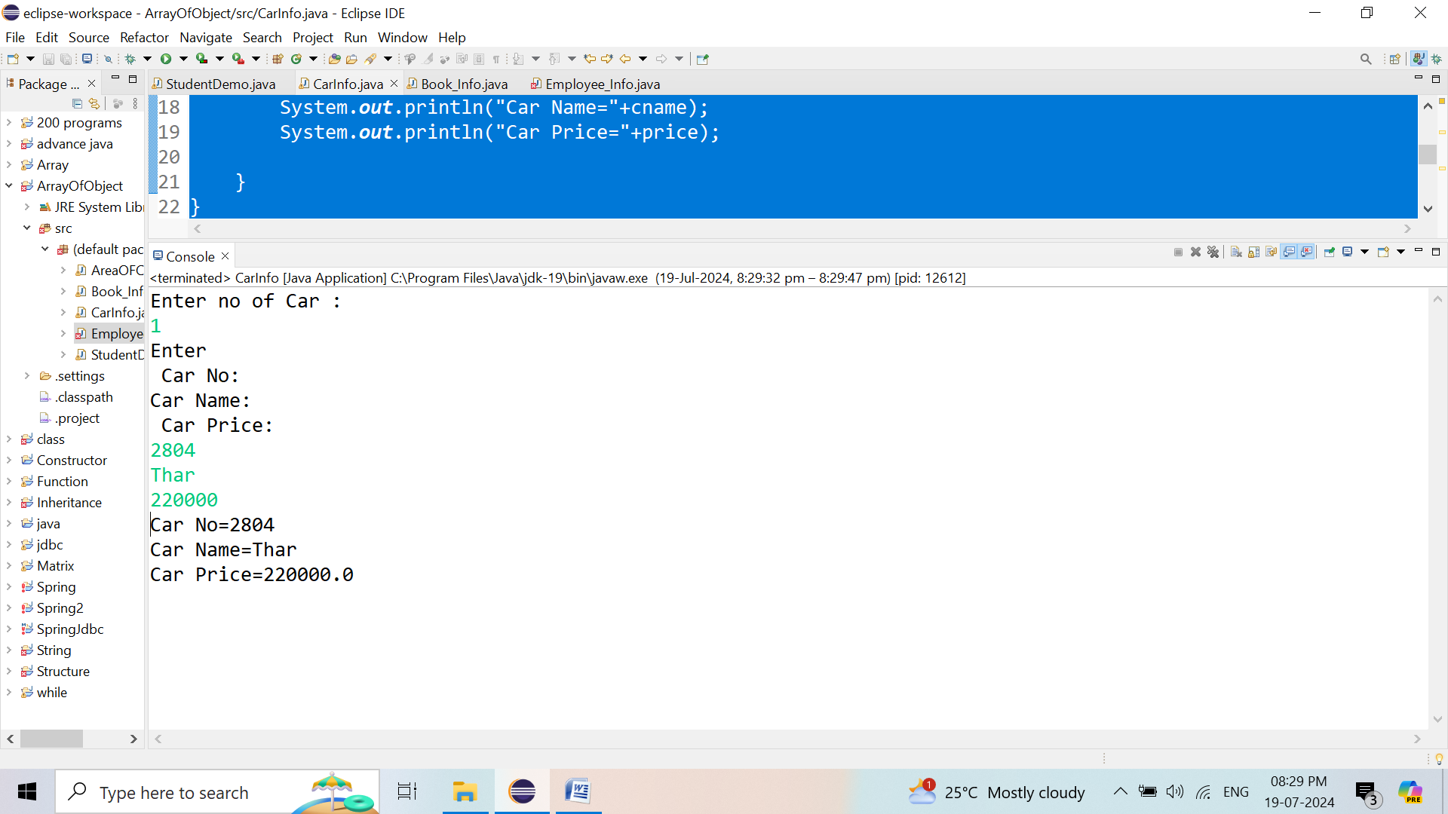

**4) Employee Info:**

**import** java.util.*;

**import** java.util.Scanner;

**class** Employee

{

**int** eid;

String ename;

String designation;

String email;

String address;

**double** salary;

**void** accept()

{

Scanner sc=**new** Scanner(System.***in***);

System.***out***.println("Enter\nEmployee Id:\nEmployee Name:\n Employee Designation:\nEmployee Email:\nEmployee Address:\nEmployee Salary:");

eid=sc.nextInt();

ename=sc.next();

designation=sc.next();

email=sc.next();

address=sc.next();

salary=sc.nextDouble();

}

**void** display()

{

System.***out***.println("Employee Id ="+eid);

System.***out***.println("Employee Name ="+ename);

System.***out***.println("Employee Designation ="+designation);

System.***out***.println("Employee Email ="+email);

System.***out***.println("Employee address ="+address);

System.***out***.println("Employee Salary ="+salary);

}

}

**public** **class** Employee_Info {

**public** **static** **void** main(String[] args) {

**int** i,n;

Scanner sc=**new** Scanner (System.***in***);

System.***out***.println("Enter no of Employee:");

n=sc.nextInt();

Employee s1[]=**new** Employee[n]; //array creation

**for**(i=0;i<n;i++)

{

s1[i]=**new** Employee(); //object creation

s1[i].accept();

s1[i].display();

}

}

}

**O/P:**

